**Gantt Chart**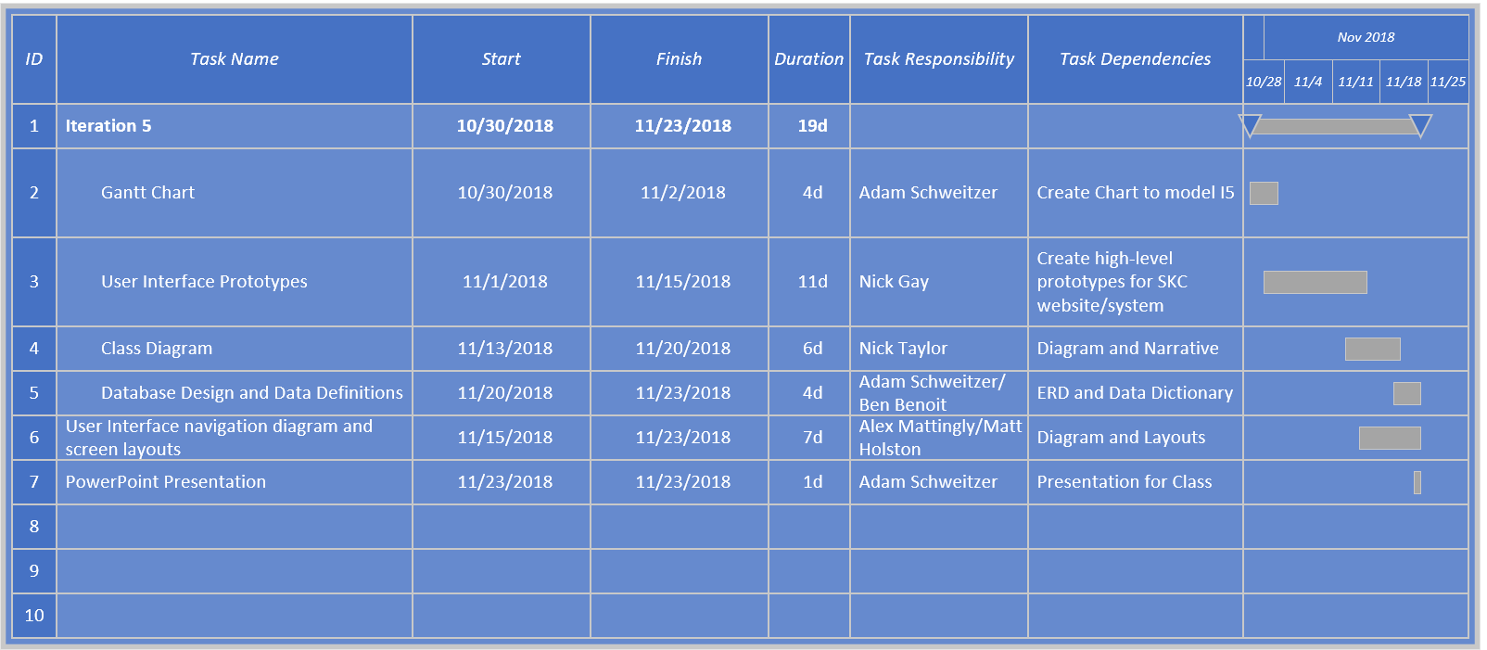

The above Gantt Chart outlines the related tasks with the start and end dates of each task. This allows for each item to be viewed as an individual flow and once each flow is completed, the whole iteration will be complete. Each Gantt Chart also list whose responsibility the task is and individual task dependencies.